MALAWI ELECTORAL SYSTEM

The electoral commission is a standalone system that is responsible for conducting the voting process. here is an online/electronic Malawi Electoral Commission, this system enables citizen to conduct electronic registration, voting and viewing result as per user requirement. Viewing results includes conducting various calculations. There is no duplication of data, it is only entered once and only primary keys are duplicated to create relationship among tables. No numbers are entered as votes but it is calculated based on the citizen/voters who voted particular candidate. all personal details of any particular kind are stored in citizen table and their IDs are used to classify them (as candidates, voters and monitors).

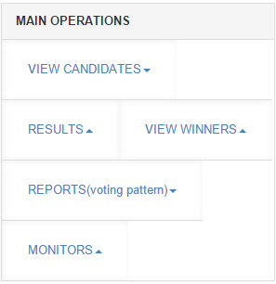**main operations** part, this part is used answer the five given queries and contain other additional queries. It is made up of list of links that are linked to queries. These list of links are nested in order to allow orderly execution on queries. Eg when you click on view winners

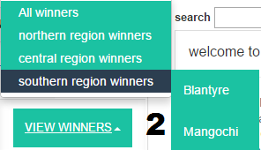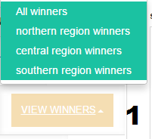

clicking view winners click on southern winners

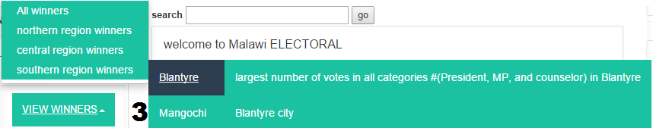

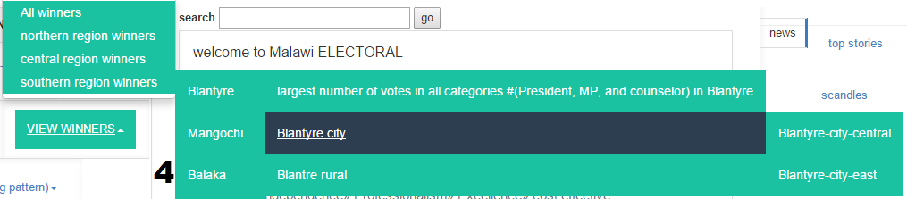click on Blantyre

finally click on Blantyre city

**QUERIES**

1. Find the poling centers where Presidential Candidate One lost by more than 5 votes to Presidential Candidate two.

SELECT polling_centre_name, votes FROM (SELECT polling_centre_name, COUNT(v.candidate_id) as votes FROM candidate c JOIN vote v ON c.candidate_id=v.candidate_id WHERE position_name = 'President' AND (represent IN (SELECT ward_name FROM ward WHERE constituency_name IN(SELECT constituency_name FROM constituency WHERE district_code IN(SELECT district_code FROM district WHERE region_name='northern')))) OR (represent IN(SELECT constituency_name FROM constituency WHERE district_code IN(SELECT district_code FROM district WHERE region_name='northern'))) GROUP BY c.candidate_id, v.polling_centre_name) AS lvote WHERE (votes-5)> SOME(SELECT COUNT(v.candidate_id) as votes FROM candidate c JOIN vote v ON c.candidate_id=v.candidate_id WHERE position_name = 'President' AND (represent IN (SELECT ward_name FROM ward WHERE constituency_name IN(SELECT constituency_name FROM constituency WHERE district_code IN(SELECT district_code FROM district WHERE region_name='northern')))) OR (represent IN(SELECT constituency_name FROM constituency WHERE district_code IN(SELECT district_code FROM district WHERE region_name='northern'))) GROUP BY c.candidate_id, v.polling_centre_name) OR (votes+5)< SOME(SELECT COUNT(v.candidate_id) as votes FROM candidate c JOIN vote v ON c.candidate_id=v.candidate_id WHERE position_name = 'President' AND (represent IN (SELECT ward_name FROM ward WHERE constituency_name IN(SELECT constituency_name FROM constituency WHERE district_code IN(SELECT district_code FROM district WHERE region_name='northern')))) OR (represent IN(SELECT constituency_name FROM constituency WHERE district_code IN(SELECT district_code FROM district WHERE region_name='northern'))) GROUP BY c.candidate_id, v.polling_centre_name)

union

SELECT polling_centre_name, votes FROM (SELECT polling_centre_name, COUNT(v.candidate_id) as votes FROM candidate c JOIN vote v ON c.candidate_id=v.candidate_id WHERE position_name = 'President' AND (represent IN (SELECT ward_name FROM ward WHERE constituency_name IN(SELECT constituency_name FROM constituency WHERE district_code IN(SELECT district_code FROM district WHERE region_name='central')))) OR (represent IN(SELECT constituency_name FROM constituency WHERE district_code IN(SELECT district_code FROM district WHERE region_name='central'))) GROUP BY c.candidate_id, v.polling_centre_name) AS lvote WHERE (votes-5)> SOME(SELECT COUNT(v.candidate_id) as votes FROM candidate c JOIN vote v ON c.candidate_id=v.candidate_id WHERE position_name = 'President' AND (represent IN (SELECT ward_name FROM ward WHERE constituency_name IN(SELECT constituency_name FROM constituency WHERE district_code IN(SELECT district_code FROM district WHERE region_name='central')))) OR (represent IN(SELECT constituency_name FROM constituency WHERE district_code IN(SELECT district_code FROM district WHERE region_name='central'))) GROUP BY c.candidate_id, v.polling_centre_name) OR (votes+5)< SOME(SELECT COUNT(v.candidate_id) as votes FROM candidate c JOIN vote v ON c.candidate_id=v.candidate_id WHERE position_name = 'President' AND (represent IN (SELECT ward_name FROM ward WHERE constituency_name IN(SELECT constituency_name FROM constituency WHERE district_code IN(SELECT district_code FROM district WHERE region_name='central')))) OR (represent IN(SELECT constituency_name FROM constituency WHERE district_code IN(SELECT district_code FROM district WHERE region_name='central'))) GROUP BY c.candidate_id, v.polling_centre_name)

union

SELECT polling_centre_name, votes FROM (SELECT polling_centre_name, COUNT(v.candidate_id) as votes FROM candidate c JOIN vote v ON c.candidate_id=v.candidate_id WHERE position_name = 'President' AND (represent IN (SELECT ward_name FROM ward WHERE constituency_name IN(SELECT constituency_name FROM constituency WHERE district_code IN(SELECT district_code FROM district WHERE region_name='southern')))) OR (represent IN(SELECT constituency_name FROM constituency WHERE district_code IN(SELECT district_code FROM district WHERE region_name='southern'))) GROUP BY c.candidate_id, v.polling_centre_name) AS lvote WHERE (votes-5)> SOME(SELECT COUNT(v.candidate_id) as votes FROM candidate c JOIN vote v ON c.candidate_id=v.candidate_id WHERE position_name = 'President' AND (represent IN (SELECT ward_name FROM ward WHERE constituency_name IN(SELECT constituency_name FROM constituency WHERE district_code IN(SELECT district_code FROM district WHERE region_name='southern')))) OR (represent IN(SELECT constituency_name FROM constituency WHERE district_code IN(SELECT district_code FROM district WHERE region_name='southern'))) GROUP BY c.candidate_id, v.polling_centre_name) OR (votes+5)< SOME(SELECT COUNT(v.candidate_id) as votes FROM candidate c JOIN vote v ON c.candidate_id=v.candidate_id WHERE position_name = 'President' AND (represent IN (SELECT ward_name FROM ward WHERE constituency_name IN(SELECT constituency_name FROM constituency WHERE district_code IN(SELECT district_code FROM district WHERE region_name='southern')))) OR (represent IN(SELECT constituency_name FROM constituency WHERE district_code IN(SELECT district_code FROM district WHERE region_name='southern'))) GROUP BY c.candidate_id, v.polling_centre_name)

This will produce the following

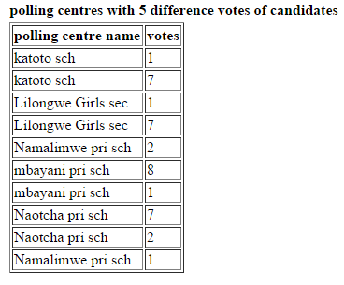

1. Produce a report of all counselors, and MPs for Blantyre city arranged in the order of constituencies and parties.

SELECT fname AS name, sname AS surname, party_code AS party, position_name AS position, represent, (SELECT COUNT(candidate_id) FROM vote WHERE vote.candidate_id=K.candidate_id ) AS votes FROM citizen c, candidate k WHERE c.citizen_id = k.citizen_id AND position_name IN('MP','councilor') AND (represent IN ( SELECT constituency_name FROM constituency WHERE constituency_name IN('Blantyre-City-central','Blantyre-City-east')) OR represent IN (SELECT ward_name FROM ward WHERE constituency_name IN('Blantyre-City-central','Blantyre-City-east')))

ORDER BY represent, party_code;

This produce the following result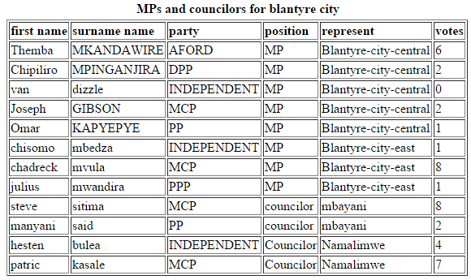

1. Find a list of all female monitors standing for all independent candidates for Blantyre urban.

SELECT fname, sname,mName, candidate_id, sex, constituency FROM citizen, monitor WHERE sex='F' AND citizen.citizen_id= monitor.citizen_id AND citizen.citizen_id IN (SELECT citizen_id FROM monitor WHERE candidate_id IN(SELECT candidate_id FROM candidate WHERE party_code='independent') AND polling_centre_name IN(SELECT polling_centre_name FROM polling_centre WHERE ward_name IN(SELECT ward_name FROM ward WHERE constituency_name IN('Blantyre-City-central','Blantyre-city-east'))));

This produces the following result

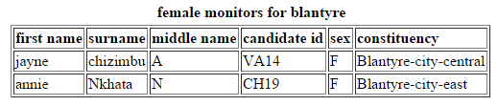

1. Find who had the largest number of votes in all categories (president, MP, and counselor) in Blantyre.

SELECT candidate.citizen_id, candidate.candidate_id, fname, sname, candidate.position_name,party_code, represent, Blantyre AS votes FROM (SELECT candidate_id, COUNT(*) AS Blantyre FROM vote WHERE polling_centre_name IN(SELECT polling_centre_name FROM polling_centre WHERE (candidate_id IN(SELECT candidate_id FROM Candidate WHERE position_name='councilor')) AND (ward_name IN(SELECT ward_name FROM ward WHERE constituency_name ='Blantyre-City-central'))) GROUP BY candidate_id) AS getID JOIN candidate ON getID.candidate_id=candidate.candidate_id JOIN citizen ON citizen.citizen_id=candidate.citizen_id WHERE Blantyre =(SELECT MAX(Blantyre) AS southernMP FROM((SELECT candidate_id AS myId, COUNT(*) AS Blantyre FROM vote WHERE polling_centre_name IN(SELECT polling_centre_name FROM polling_centre WHERE (candidate_id IN(SELECT candidate_id FROM Candidate WHERE position_name='councilor')) AND (ward_name IN(SELECT ward_name FROM ward WHERE constituency_name='Blantyre-City-central'))) GROUP BY candidate_id) AS derived))

union

SELECT candidate.citizen_id, candidate.candidate_id, fname, sname, candidate.position_name,party_code, represent, Blantyre AS votes FROM (SELECT candidate_id, COUNT(*) AS Blantyre FROM vote WHERE polling_centre_name IN(SELECT polling_centre_name FROM polling_centre WHERE (candidate_id IN(SELECT candidate_id FROM Candidate WHERE position_name='MP')) AND (ward_name IN(SELECT ward_name FROM ward WHERE constituency_name='Blantyre-City-central'))) GROUP BY candidate_id) AS getID JOIN candidate ON getID.candidate_id=candidate.candidate_id JOIN citizen ON citizen.citizen_id=candidate.citizen_id WHERE Blantyre =(SELECT MAX(Blantyre) AS southernMP FROM((SELECT candidate_id AS myId, COUNT(*) AS Blantyre FROM vote WHERE polling_centre_name IN(SELECT polling_centre_name FROM polling_centre WHERE (candidate_id IN(SELECT candidate_id FROM Candidate WHERE position_name='MP')) AND (ward_name IN(SELECT ward_name FROM ward WHERE constituency_name='Blantyre-City-central'))) GROUP BY candidate_id) AS derived))

Union

#councilor list from blantyre city east

SELECT candidate.citizen_id, candidate.candidate_id, fname, sname, candidate.position_name,party_code, represent, Blantyre AS votes FROM (SELECT candidate_id, COUNT(*) AS Blantyre FROM vote WHERE polling_centre_name IN(SELECT polling_centre_name FROM polling_centre WHERE (candidate_id IN(SELECT candidate_id FROM Candidate WHERE position_name='councilor')) AND (ward_name IN(SELECT ward_name FROM ward WHERE constituency_name='Blantyre-rural'))) GROUP BY candidate_id) AS getID JOIN candidate ON getID.candidate_id=candidate.candidate_id JOIN citizen ON citizen.citizen_id=candidate.citizen_id WHERE Blantyre =( SELECT MAX(Blantyre) AS southernMP FROM((SELECT candidate_id AS myId, COUNT(*) AS Blantyre FROM vote WHERE polling_centre_name IN(SELECT polling_centre_name FROM polling_centre WHERE (candidate_id IN(SELECT candidate_id FROM Candidate WHERE position_name='councilor')) AND (ward_name IN(SELECT ward_name FROM ward WHERE constituency_name='Blantyre-rural'))) GROUP BY candidate_id) AS derived))

union

SELECT candidate.citizen_id, candidate.candidate_id, fname, sname, candidate.position_name,party_code, represent, Blantyre AS votes FROM (SELECT candidate_id, COUNT(*) AS Blantyre FROM vote WHERE polling_centre_name IN(SELECT polling_centre_name FROM polling_centre WHERE (candidate_id IN(SELECT candidate_id FROM Candidate WHERE position_name='MP')) AND (ward_name IN(SELECT ward_name FROM ward WHERE constituency_name='Blantyre-rural'))) GROUP BY candidate_id) AS getID JOIN candidate ON getID.candidate_id=candidate.candidate_id JOIN citizen ON citizen.citizen_id=candidate.citizen_id WHERE Blantyre =( SELECT MAX(Blantyre) AS southernMP FROM(( SELECT candidate_id AS myId, COUNT(*) AS Blantyre FROM vote WHERE polling_centre_name IN(SELECT polling_centre_name FROM polling_centre WHERE (candidate_id IN(SELECT candidate_id FROM Candidate WHERE position_name='MP')) AND (ward_name IN(SELECT ward_name FROM ward WHERE constituency_name='Blantyre-rural'))) GROUP BY candidate_id) AS derived))

union

#councilor list from blantyre city east

SELECT candidate.citizen_id, candidate.candidate_id, fname, sname, candidate.position_name,party_code, represent, Blantyre AS votes FROM (SELECT candidate_id, COUNT(*) AS Blantyre FROM vote WHERE polling_centre_name IN(SELECT polling_centre_name FROM polling_centre WHERE (candidate_id IN(SELECT candidate_id FROM Candidate WHERE position_name='councilor')) AND (ward_name IN(SELECT ward_name FROM ward WHERE constituency_name ='Blantyre-City-east'))) GROUP BY candidate_id) AS getID JOIN candidate ON getID.candidate_id=candidate.candidate_id JOIN citizen ON citizen.citizen_id=candidate.citizen_id WHERE Blantyre =( SELECT MAX(Blantyre) AS southernMP FROM((SELECT candidate_id AS myId, COUNT(*) AS Blantyre FROM vote WHERE polling_centre_name IN(SELECT polling_centre_name FROM polling_centre WHERE (candidate_id IN(SELECT candidate_id FROM Candidate WHERE position_name='councilor')) AND (ward_name IN(SELECT ward_name FROM ward WHERE constituency_name='Blantyre-City-east'))) GROUP BY candidate_id) AS derived))

union

#mp candidate for blantyre city east

SELECT candidate.citizen_id, candidate.candidate_id, fname, sname, candidate.position_name,party_code, represent, Blantyre AS votes FROM (SELECT candidate_id, COUNT(*) AS Blantyre FROM vote WHERE polling_centre_name IN(SELECT polling_centre_name FROM polling_centre WHERE (candidate_id IN(SELECT candidate_id FROM Candidate WHERE position_name='MP')) AND (ward_name IN(SELECT ward_name FROM ward WHERE constituency_name ='Blantyre-City-east'))) GROUP BY candidate_id) AS getID JOIN candidate ON getID.candidate_id=candidate.candidate_id JOIN citizen ON citizen.citizen_id=candidate.citizen_id WHERE Blantyre =(SELECT MAX(Blantyre) AS southernMP FROM((SELECT candidate_id AS myId, COUNT(*) AS Blantyre FROM vote WHERE polling_centre_name IN(SELECT polling_centre_name FROM polling_centre WHERE (candidate_id IN(SELECT candidate_id FROM Candidate WHERE position_name='MP')) AND (ward_name IN(SELECT ward_name FROM ward WHERE constituency_name='Blantyre-City-east'))) GROUP BY candidate_id) AS derived))

union

#selec maximum votes from the south

SELECT citizen_id, candidate_id, fname, sname, position_name, party_code, represent, MAX(votes) AS maximum FROM (SELECT citizen.citizen_id, candidate.candidate_id, fname, sname, position_name, party_code, represent, (SELECT COUNT(candidate_id) AS vID FROM vote WHERE vote.candidate_id=candidate.candidate_id AND position_name='President' AND (vote.polling_centre_name IN(SELECT polling_centre_name FROM polling_centre WHERE ward_name IN (SELECT ward_name FROM ward WHERE constituency_name IN (SELECT constituency_name FROM constituency WHERE district_code IN(SELECT district_code FROM district WHERE region_name='southern')))))) AS votes FROM candidate LEFT JOIN citizen ON citizen.citizen_id=Candidate.citizen_id WHERE position_name='President') AS myTable GROUP BY citizen_id, candidate_id, fname, sname, position_name, party_code, represent HAVING maximum=(SELECT MAX(votes) AS maximum FROM(SELECT citizen.citizen_id, candidate.candidate_id, fname, sname, position_name,party_code, represent, (SELECT COUNT(candidate_id) AS vID FROM vote WHERE vote.candidate_id=candidate.candidate_id AND position_name='President' AND (vote.polling_centre_name IN(SELECT polling_centre_name FROM polling_centre WHERE ward_name IN (SELECT ward_name FROM ward WHERE constituency_name IN (SELECT constituency_name FROM constituency WHERE district_code IN(SELECT district_code FROM district WHERE region_name='southern')))))) AS votes FROM candidate LEFT JOIN citizen ON citizen.citizen_id=Candidate.citizen_id WHERE position_name='President') AS myTable)

This produces the folowwing result

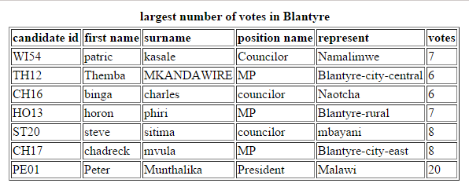

1. Produce a report on regional voting patterns for presidents, MP's and counselors. i.e. how many people from the southern region voted for southern region members, etc.

SELECT region, COUNT(DISTINCT v.citizen_id) AS votes FROM vote v JOIN citizen ci ON v.citizen_id=ci.citizen_id WHERE (ci.citizen_id IN(SELECT citizen_id FROM citizen WHERE constituency IN(SELECT constituency_name FROM constituency WHERE district_code IN(SELECT district_code FROM district WHERE region_name=(SELECT region_name FROM region WHERE region_name='northern'))))) AND region='northern' AND (v.polling_centre_name IN (SELECT polling_centre_name FROM polling_centre WHERE ward_name IN(SELECT ward_name FROM ward WHERE constituency_name IN(SELECT constituency_name FROM constituency WHERE district_code IN(SELECT district_code FROM district WHERE region_name=(SELECT region_name FROM region WHERE region_name='northern')))))) GROUP BY region

union

SELECT region, COUNT(DISTINCT v.citizen_id) AS votes FROM vote v JOIN citizen ci ON v.citizen_id=ci.citizen_id WHERE (ci.citizen_id IN(SELECT citizen_id FROM citizen WHERE constituency IN(SELECT constituency_name FROM constituency WHERE district_code IN(SELECT district_code FROM district WHERE region_name=(SELECT region_name FROM region WHERE region_name='central'))))) AND region='central' AND (v.polling_centre_name IN (SELECT polling_centre_name FROM polling_centre WHERE ward_name IN(SELECT ward_name FROM ward WHERE constituency_name IN(SELECT constituency_name FROM constituency WHERE district_code IN(SELECT district_code FROM district WHERE region_name=(SELECT region_name FROM region WHERE region_name='central')))))) GROUP BY region

union

SELECT region, COUNT(DISTINCT v.citizen_id) AS votes FROM vote v JOIN citizen ci ON v.citizen_id=ci.citizen_id WHERE (ci.citizen_id IN(SELECT citizen_id FROM citizen WHERE constituency IN(SELECT constituency_name FROM constituency WHERE district_code IN(SELECT district_code FROM district WHERE region_name=(SELECT region_name FROM region WHERE region_name='southern'))))) AND region='southern' AND (v.polling_centre_name IN (SELECT polling_centre_name FROM polling_centre WHERE ward_name IN(SELECT ward_name FROM ward WHERE constituency_name IN(SELECT constituency_name FROM constituency WHERE district_code IN(SELECT district_code FROM district WHERE region_name=(SELECT region_name FROM region WHERE region_name='southern')))))) GROUP BY region

This query produces the following result.

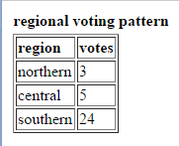

**ADDITIONAL QUERIES**

in order to run the system effectively, details must be entered in order for example for you to vote you need to be a citizen therefore you need to register first with proper details otherwise if your location is unidentified then you cannot vote because system will not know which list of candidate are available for you and data duplication is not allowed by checking if entered details are available to database. Every voter is given candidates from his or her constituency. Only manual entering of votes allows candidate to vote for any candidate at any location but this electronic one restrict that.